DAL

namespace Data_Access_Layer.Repository.Entities

{

public class City

{

public int Id { get; set; }

public string Name { get; set; }

}

}

using Data_Access_Layer.Repository;

using Data_Access_Layer.Repository.Entities;

namespace Data_Access_Layer

{

public class CityDal

{

private StudenttDBContext _context;

public CityDal( )

{

_context = new StudenttDBContext();

}

public List<City> GetCities()

{

return _context.Cities.ToList();

}

public void AddCity(City city)

{

_context.Cities.Add(city);

_context.SaveChanges();

}

}

}

BAL

using Data_Access_Layer;

//using Data_Access_Layer.Repository.Entities;

using Business_Access_Layer.Models;

using AutoMapper;

using Data_Access_Layer.Repository.Entities;

namespace Business_Access_Layer

{

public class CityBal

{

private Data_Access_Layer.CityDal _dal;

private Mapper _mapper;

public CityBal()

{

_dal = new Data_Access_Layer.CityDal();

}

public List<City> GetCities()

{

List<City> cities = _dal.GetCities();

return cities;

}

public void AddCity(City city)

{

_dal.AddCity(city);

}

}

}

Web Api

//using Data_Access_Layer.Repository.Entities;

using Business_Access_Layer.Models;

using Data_Access_Layer.Repository.Entities;

using Microsoft.AspNetCore.Http;

using Microsoft.AspNetCore.Mvc;

namespace WebApi.Controllers

{

[Route("api/[controller]")]

[ApiController]

[ApiVersion("1.0")]

[ApiVersion("2.0")]

[Route("api/v{version:apiVersion}/student")]

public class CityController : ControllerBase

{

private Business_Access_Layer.CityBal _bal;

public CityController() {

_bal = new Business_Access_Layer.CityBal();

}

[HttpGet,MapToApiVersion("1.0")]

//[Route("getstudents")]

public List<City> GetCities()

{

return _bal.GetCities();

}

[HttpGet, MapToApiVersion("2.0")]

//[Route("getnames")]

public List<string> GetNames()

{

return new List<string>() { "aa", "bb", "cc", "dd" };

}

[HttpPost]

public void Add(City city)

{

_bal.AddCity(city);

}

}

}

After performing Post oprration, we will add more properties

namespace Data_Access_Layer.Repository.Entities

{

public class City

{

public int Id { get; set; }

public string Name { get; set; }

public int UpdatedBy { get; set; }

public DateTime UpdatedOn { get; set; }

}

}

Do migration agaian

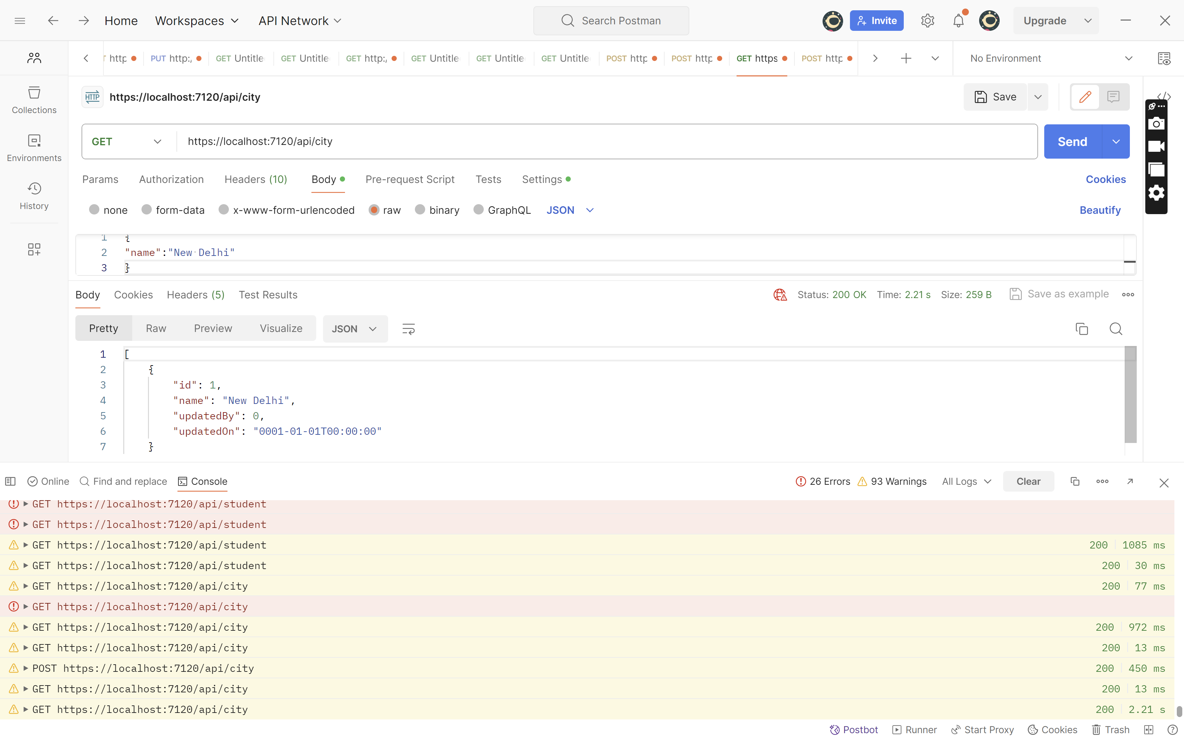

We want to hide details like UpdatedBy, UpdatedOn, They are of no use to clients

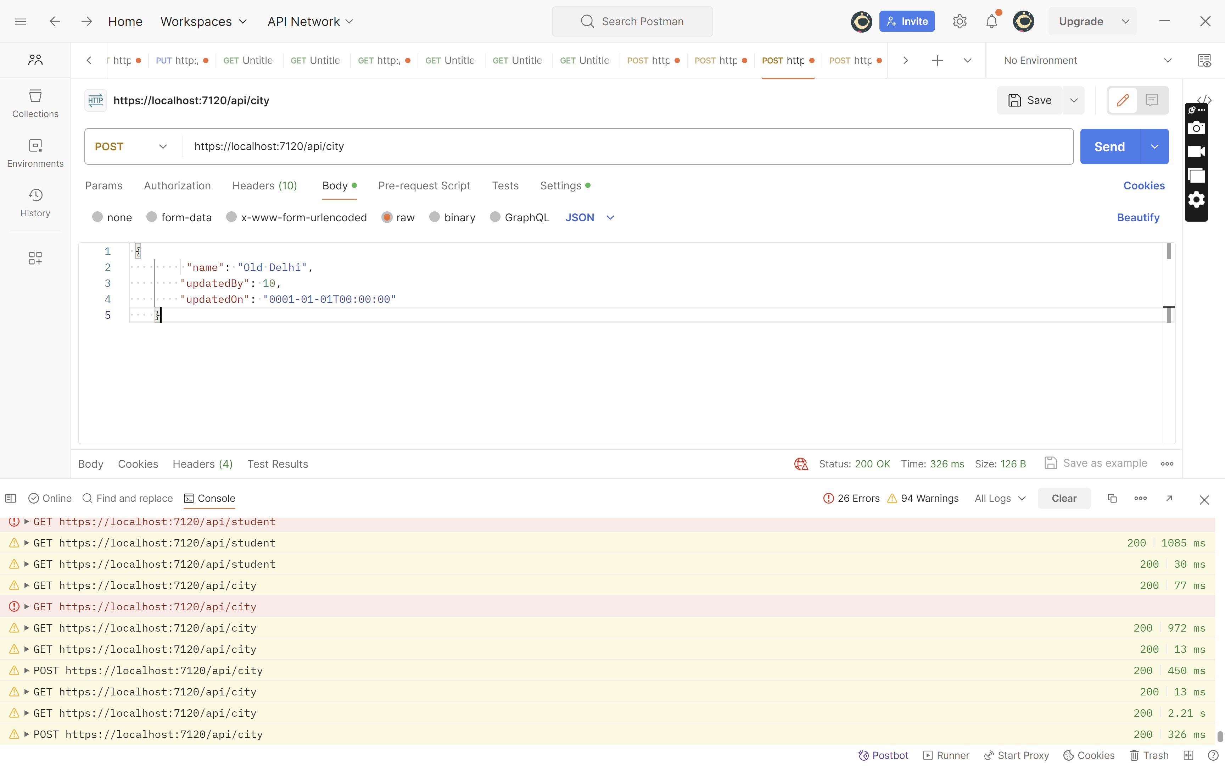

Add DTO’s folder in Web Api

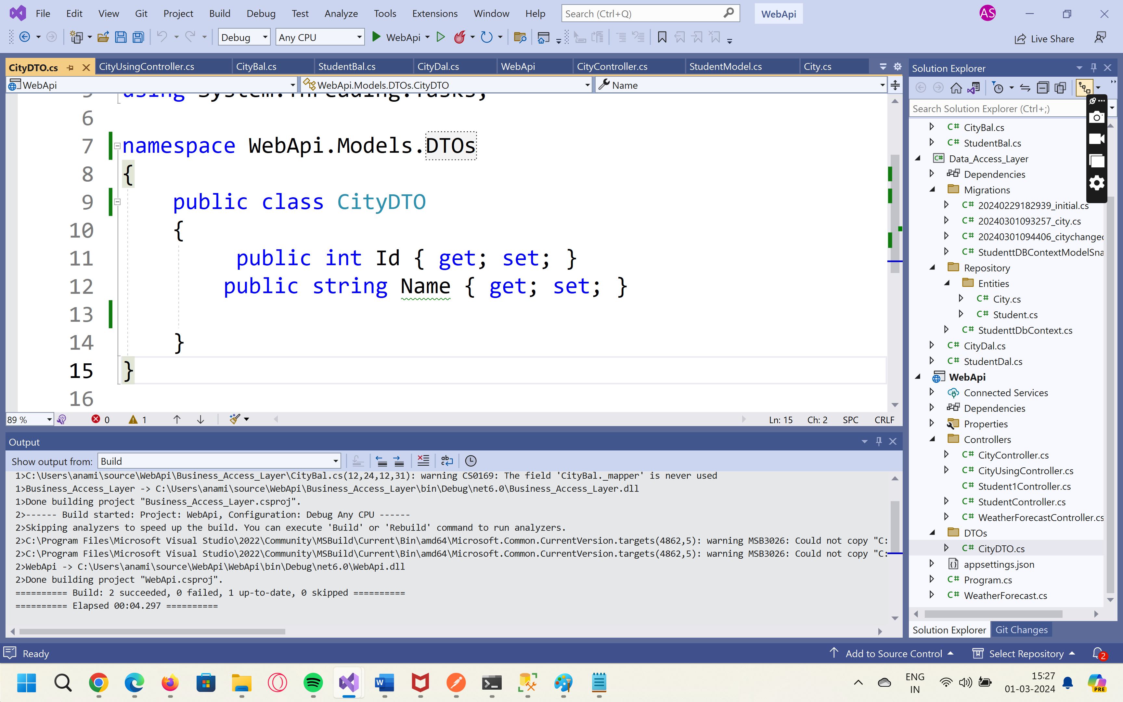

//using Data_Access_Layer.Repository.Entities;

using Business_Access_Layer.Models;

using Data_Access_Layer.Repository.Entities;

using Microsoft.AspNetCore.Http;

using Microsoft.AspNetCore.Mvc;

using WebApi.Models.DTOs;

namespace WebApi.Controllers

{

[Route("api/[controller]")]

[ApiController]

[ApiVersion("1.0")]

[ApiVersion("2.0")]

[Route("api/v{version:apiVersion}/student")]

public class CityUsingDTOController : ControllerBase

{

private Business_Access_Layer.CityBal _bal;

public CityUsingDTOController() {

_bal = new Business_Access_Layer.CityBal();

}

[HttpGet,MapToApiVersion("1.0")]

//[Route("getstudents")]

public List<CityDTO> GetCities()

{

List<City> cities = _bal.GetCities();

List<CityDTO> cities2= new List<CityDTO>();

foreach(var city in cities)

{

CityDTO cityDTO = new CityDTO()

{

Id = city.Id,

Name = city.Name,

};

cities2.Add(cityDTO);

}

return cities2;

}

[HttpGet, MapToApiVersion("2.0")]

//[Route("getnames")]

public List<string> GetNames()

{

return new List<string>() { "aa", "bb", "cc", "dd" };

}

//[HttpGet("{id}")]

//public StudentModel GetStudent(int id)

//{

// return _bal.GetStudent(id);

//}

[HttpPost]

public void Add(CityDTO cityDto)

{

var city = new City()

{

Name = cityDto.Name,

UpdatedBy = 100,

UpdatedOn = DateTime.Now

};

_bal.AddCity(city);

}

}

}